Merge join algorithm

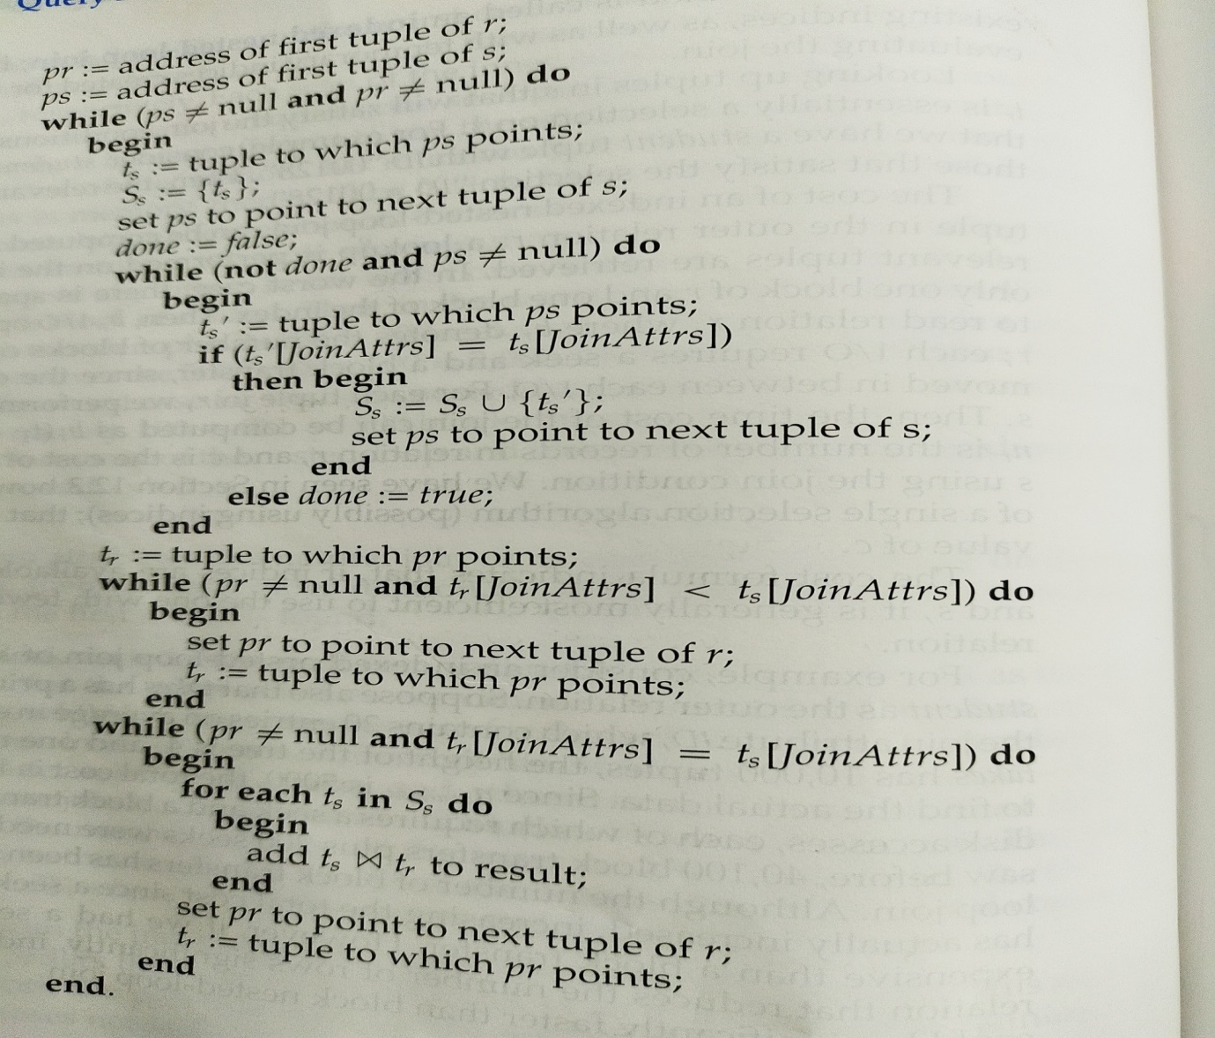

Pr and Ps point to first tuple of r and s respectively.

1st while loop-

S={ts U ts’}

Ps++

2nd while loop-

If tr[join attributevalue]<ts[join attributevalue]

Pr++

3rd while loop-

Tr.ts for common join attribute values

Pr++

Example

|  |  |  |  |  |  |  |
| --- | --- | --- | --- | --- | --- | --- |
|  | R | |  |  | S | |
|  | a1 | a2 |  |  | a1 | a3 |
| Pr | a | 1 |  | Ps | a | X |
|  | b | 2 |  |  | b | Y |
|  | b | 3 |  |  | c | Z |
|  | d | 4 |  |  | d | A |

Join attribute is a

Pr-🡪 a 1 , Ps🡪a X tr is tuple pointed by Pr and ts is tuple pointed by Ps.

1st while loop

In S find all tuples with same join attribute value (a).As S is sorted ,once we reach to b in s ,it’s indication that ‘a’ will not present after that.

|  |  |  |  |  |  |  |
| --- | --- | --- | --- | --- | --- | --- |
|  | R | |  |  | S | |
|  | a1 | a2 |  |  | a1 | a3 |
| Pr | a | 1 |  |  | a | X |
|  | b | 2 |  | Ps | b | Y |
|  | b | 3 |  |  | c | Z |
|  | d | 4 |  |  | d | A |

S={ts}-(a,X)

2nd while loop

If tr(a) < ts(a)- no - come out of loop

3rd while loop

tr(a) <=ts(a) join

a 1 X

increment Pr

|  |  |  |  |  |  |  |
| --- | --- | --- | --- | --- | --- | --- |
|  | R | |  |  | S | |
|  | a1 | a2 |  |  | a1 | a3 |
|  | a | 1 |  |  | a | X |
| Pr | b | 2 |  | Ps | b | Y |
|  | b | 3 |  |  | c | Z |
|  | d | 4 |  |  | d | A |

1st while loop

In S find all tuples with same join attribute value (b).As S is sorted ,once we reach to c in S ,it’s indication that ‘b’ will not present after that.

S={ts}-(b,Y)

2nd while loop

If tr(b) < ts(b) -no –come out of loop

3rd while loop

tr(a) <=ts(a) join

a 1 X

increment Pr